Login and Registering Testing

Test 1:

Input: Nonexistent user

Username – f

Password - f

Expected Output: Should not allow them to access the game and should give feedback that there was an error.

Output:

Incorrect details

Test 2:

Input: Existing user

Username – Lachlan

Password – a

Expected Output: The server should then continue onto the game

Output:

Game screen was launched

Test 3:

Input: Registering a new user

Email– [saj@gmail.com](mailto:saj@gmail.com)

Username – saj1

Password – web

Expected output: Return to login screen

Output:

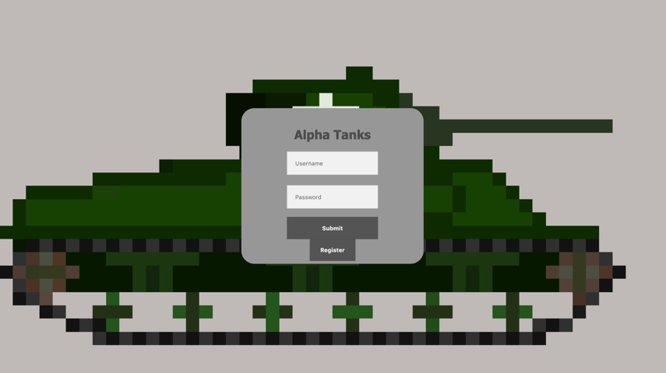

Returns user to login in screen

Test 4:

Input: Registering a new user who already exists.

Email - [robert@gmail.com](mailto:robert@gmail.com)

Username – Robert

Password – password

Expected output: should return to login screen and inform this user exist

Output:

Returns to login screen and informs them user exist